Class 1:
Start class with “Om”/“Prarthana” – Ham ko munn ki Shakti tena video/Audio

Namaste Bachchon/Namaste Mausi
Mera naam ________________ hai
Apka naam kya hai?
Mera naam ________________ hai
Aap Kaise Hai/ Mai Thik Hun/Mai achcha hun/Mai achchi hun
Aaj Ravivar hai
Kal Shanivar tha
Kal Somvar hai

Where is India on the globe and which language/s does country speaks?
India is in the Asia continent. It is surrounded by ocean surrounding its three sides, east-west-south and north has the tallest mountains in the world called Everest mountains.

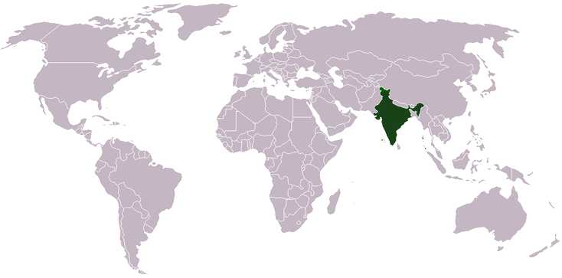
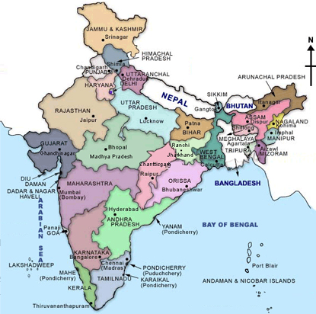
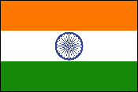
Each color on the flag represents something different:
Saffron represents stands for courage and sacrifice. White represents peace, unity and truth. Green stands for faith and fertility. The blue symbolizes the sky and the ocean.
Dharma Chakra
In the center of the white band is a blue wheel with 24 spokes. This is the Dharma Chakra (or “Wheel of Law”). The Chakra represents the continuing progress of the nation and the importance of justice in life.
India is a federal union of states comprising twenty-eight states and seven union territories. There are 18 official languages in India. Depending on the states, you can see people speak different languages, so one language is needed for national language. So, it is decided on jan 25th, 1950 that Hindi will be the national language for all the official work as many people speak Hindi.
States:
- Andhra Pradesh  - Arunachal Pradesh  - Assam  - Bihar  - Chhattisgarh  - Goa  - Gujarat | - Haryana  - Himachal Pradesh  - Jammu and Kashmir  - Jharkhand  - Karnataka  - Kerala  - Madhya Pradesh | - Maharashtra  - Manipur  - Meghalaya  - Mizoram  - Nagaland  - Orissa  - Punjab | - Rajasthan  - Sikkim  - Tamil Nadu  - Tripura  - Uttar Pradesh  - Uttarakhand  - West Bengal
Union Territories:
- Andaman and Nicobar Islands
- Chandigarh
- Dadra and Nagar Haveli
- Daman and Diu
- Lakshadweep
- National Capital Territory of Delhi
- Puducherry

Language | Family | Speakers (2001, in millions)^{[22]} |  | State(s)
Assamese/Axomiya | Indo-Aryan, Eastern | 13 |  | Assam, Arunachal Pradesh
Bengali | Indo-Aryan, Eastern | 83 in India |  | West Bengal, Tripura, Andaman & Nicobar Islands and also few regions of Assam
Bodo | Tibeto-Burman | 1.4 |  | Assam
Dogri | Indo-Aryan, Northwestern | 2.3 |  | Jammu and Kashmir
Gujarati | Indo-Aryan, Western | 46 |  | Dadra and Nagar Haveli, Daman and Diu, Gujarat
Standard Hindi | Indo-Aryan, Central | unknown^{[23]} |  | Andaman and Nicobar Islands, Arunachal Pradesh, Bihar, Chandigarh, Chhattisgarh, the national capital territory of Delhi, Haryana, Himachal Pradesh, Jharkhand, Madhya Pradesh, Rajasthan, Uttar Pradesh and Uttarakhand
Kannada | Dravidian | 38 |  | Karnataka
Kashmiri | Indo-Aryan, Dardic | 5.5 |  | Jammu and Kashmir
Konkani | Indo-Aryan, Southern | 2.5 (7.6 per Ethnologue) |  | Goa, Karnataka, Maharashtra, Kerala
Maithili | Indo-Aryan, Eastern | 12 (32 in India in 2000 per Ethnologue) |  | Bihar
Malayalam | Dravidian | 33 |  | Kerala, Andaman and Nicobar Islands, Lakshadweep, Puducherry
Manipuri (also Meitei or Meithei) | Tibeto-Burman | 1.5 |  | Manipur
Marathi | Indo-Aryan, Southern | 72 |  | Maharashtra, Goa, Dadra & Nagar Haveli, Daman and Diu, Madhya Pradesh, Karnataka
Nepali | Indo-Aryan, Northern | 2.9 in India |  | Sikkim, West Bengal, Assam
Oriya | Indo-Aryan, Eastern | 33 |  | Orissa
Punjabi | Indo-Aryan, Northwestern | 29 in India |  | Chandigarh, Delhi, Haryana, Punjab
Sanskrit | Indo-Aryan | 0.01 |  | non-regional
Santhali | Munda | 6.5 |  | Santhal tribals of the Chota Nagpur Plateau (comprising the states of Bihar, Chattisgarh, Jharkhand, Orissa)
Sindhi | Indo-Aryan, Northwestern | 2.5 in India |  | non-regional
Tamil | Dravidian | 61 |  | Tamil Nadu, Andaman & Nicobar Islands, Puducherry
Telugu | Dravidian | 74 |  | Andaman & Nicobar Islands, Andhra Pradesh, Puducherry
Urdu | Indo-Aryan, Central | 52 in India |  | Jammu and Kashmir, Andhra Pradesh, Delhi, Bihar, Uttar Pradesh

Origins of the language and its deep relationship with Sanskrit:
Sanskrit, one of the most ancient spoken and written languages in the world and one of the earliest members of the Indo-European language family, is the primary source of Hindi. Hindi, like Sanskrit, is written in the Dev Naagari script, which is common to several other Indian languages as well. Much of the vocabulary of Hindi comes from Sanskrit, though Hindi also has a special relationship with Urdu, their grammar and much of their vocabulary being identical.
English words borrowed from Hindi:
Many words were assimilated into English when India was the colony of Britain. Most are formally recognized by scholars as borrowed from Hindi while there are disputes about a few. Following are some of the words borrowed from Hindi and its parent language(s).
‘Bazaar’ – Market, street lined with shops
‘Bungalow’ – Spacious house
‘Coolie’ (cooly) – Unskilled laborer, normally porters in India
‘Guru’ – Teacher / Guide / Mentor
‘Khaki’ - Sturdy cloth of this color (light olive brown to moderate or light yellowish brown)
‘Loot’ - To pillage, spoil
‘Pundit’ - A learned person, source of opinion
Other facts about Hindi:
* The script being phonetic, Hindi, unlike English, is pronounced as it is written and thus, comparatively easy to learn.
* There are 33 consonants and 11 vowels in Hindi. Additionally, there are also many conjunct consonants.
* All Hindi letters have at least a partial bar at the top, which connects to the other letters in a word. There are no uppercase or lowercase forms for Hindi letters.
* Hindi's popularity has been boosted by Bollywood, the Hindi film industry. These movies are now starting to have an international appeal (largely aided by the huge Indian diaspora abroad) and have broken into the western markets as well.
* A survey in 1997 found that 66% of all Indians can speak Hindi, and 77% of the Indians regard Hindi as "one language across the nation".
Story about Rabbit and tortoise
Prayer at the end of the class – Asto Maa Sad Gamaya

hum ko man kee shakti denaa, man wijay kare
God, please give us the strength of mind, so that we can win victory over our minds
dusaron kee jay se pahale, khud ko jay kare
So that we can become victorious over own self, before winning over others
Bhed bhaaw apane dil se saaf kar sake
Remove the feelings of differences from our hearts
doston se bhool ho to maaf kar sake
Make us forgive when friends commit mistakes
zoothh se bache rahe, sach kaa dam bhare
Keep us always away from falsehood, and fill our hearts only with truth
dusaron kee jay se pahale, khud ko jay kare
Make us win our own self before winning over others
mushkile pade to hum pe itanaa karam kar
If trouble befall on us, please this much grace on us
saath de to dharam kaa, chale to dharam kar
So that we can tread the path of religion and perform our duties
khud pe hausalaa rahe, badee se naa dare
Please make us confident and fearless
dusaron kee jay se pahale, khud ko jay kare
Make us win our own self before winning over others
Asato Maa Sad Gamaya Oh Lord, lead me from untruth to truth,
Tamaso Maa Jyotir Gamaya from darkness to light,
Mrityor Maa Amritam Gamaya from death to immortality.
Om Shanti Shanti Shanti Peace, Peace Peace.
Complete Surrender to God

